Implement Effective Alerting

Overview

Prometheus comes with a built-in alerting mechanism through the Alertmanager. It continuously evaluates rules based on collected metrics and triggers alerts when a specified condition is met.
Alerts are defined using Prometheus Alert Rules, and these alerts can be routed to various endpoints such as Slack, email, PagerDuty, and others. For this guide, we’ll focus on the integration with Grafana to display the alerts visually.

Key Concepts:
- Prometheus Rules: Define the conditions for alerts based on metrics.
- Alertmanager: Handles and routes alerts generated by Prometheus.
- Grafana Alerts Panel: Visualizes active alerts and their severity.

Prerequisites

- Ubuntu
- Prometheus installed
- Grafana installed
- Valid SMTP email account with credentials (App Password if using Gmail)
- Basic Linux & YAML configuration knowledge

Step 1: Define the Alert Rule

- Open Ubuntu

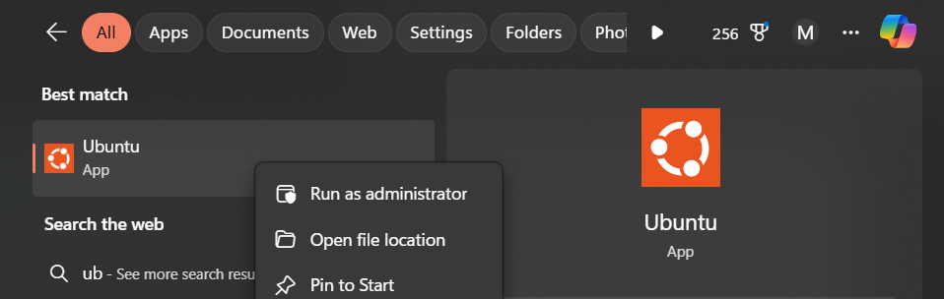

- Run Prometheus using the following command:
  - sudo systemctl start prometheus

Alert rules in Prometheus are typically defined in a YAML file. These rules determine when to trigger an alert based on specific metric thresholds.

- Create a new rule file (e.g., alerts.yml):
sudo nano /etc/prometheus/alerts.yml

Define the rule like this:
groups:
- name: TestAlerts
rules:
- alert: AlwaysFiring
expr: vector(1)
for: 0s
labels:
severity: critical
annotations:
summary: "This alert is always firing"
description: "Used for testing alerts in Grafana"

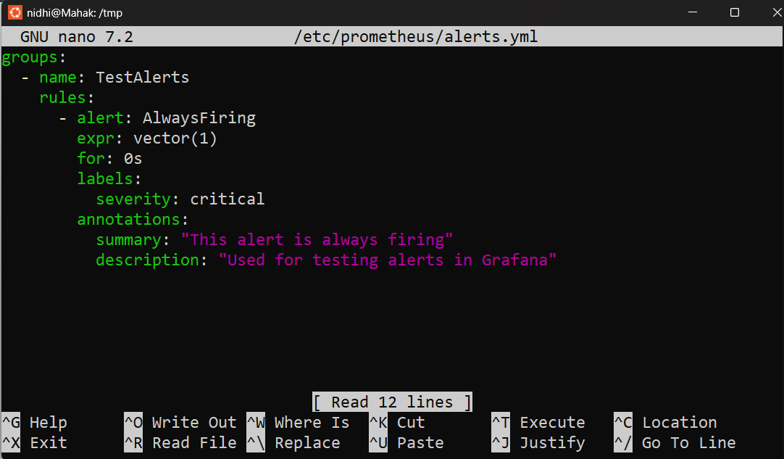

(This alert rule creates an alert called AlwaysFiring that continuously stays active. It is mainly used to test and verify that the alerting system (Prometheus → Alertmanager → Grafana) is working correctly by generating a constant alert.)

Step 2: Add Alert Rule to Prometheus

- include it in your prometheus.yml configuration:
rule_files:
- “alert.rules.yml”

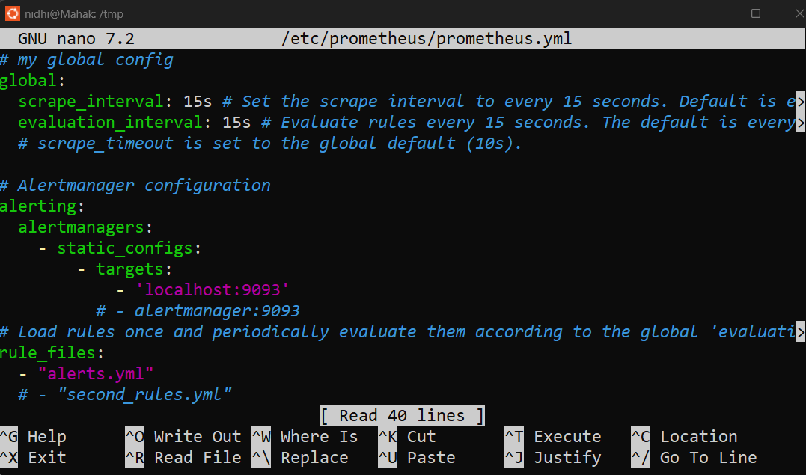

- Restart Prometheus to apply the new configuration:
  - sudo systemctl restart prometheus

Setting Up Alertmanager

Prometheus doesn’t handle alert notifications by itself. Instead, it sends alerts to the Alertmanager, which can be configured to route alerts to email, Slack, or other communication tools.

- Install Alertmanager:
cd /tmp
AM_TAG=$(curl -s https://api.github.com/repos/prometheus/alertmanager/releases/latest | grep -Po '"tag_name": "\K.*?(?=")')
AM_VER=${AM_TAG#v}
wget https://github.com/prometheus/alertmanager/releases/download/${AM_TAG}/alertmanager-${AM_VER}.linux-amd64.tar.gz

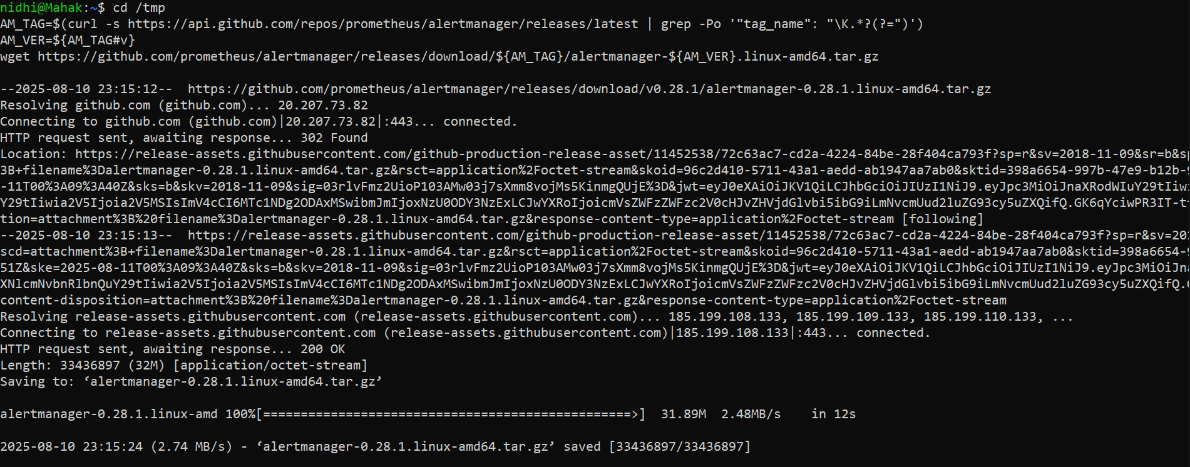

- Extract and install:

tar xvf alertmanager-${AM_VER}.linux-amd64.tar.gz
sudo cp alertmanager-${AM_VER}.linux-amd64/alertmanager /usr/local/bin/
sudo cp alertmanager-${AM_VER}.linux-amd64/amtool /usr/local/bin/
sudo mkdir -p /etc/alertmanager /var/lib/alertmanager
sudo chown -R prometheus:prometheus /etc/alertmanager /var/lib/alertmanager

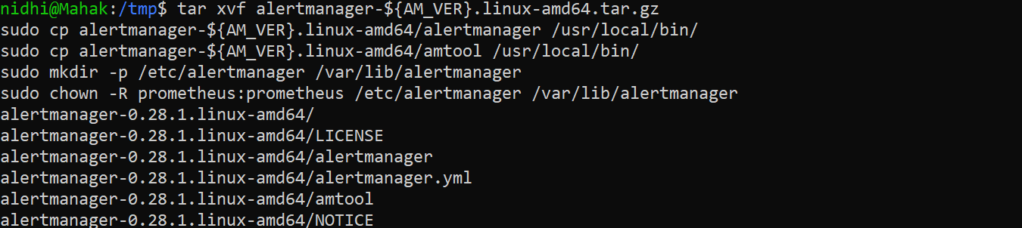

- Create a simple configuration file for Alertmanager (alertmanager.yml):
  - sudo nano /etc/alertmanager/alertmanager.yml
Write:

route:
receiver: 'Nidhi'
receivers:
- name: 'Nidhi'
email_configs:
- to: 'jhanidhinj34@gmail.com'
from: 'mehakyadav1502@gmail.com'
smarthost: 'smtp.gmail.com:587'
auth_username: 'mehakyadav1502@gmail.com'
auth_password: 'bmkl pzan misn cxpa'

(change this according to your informations)

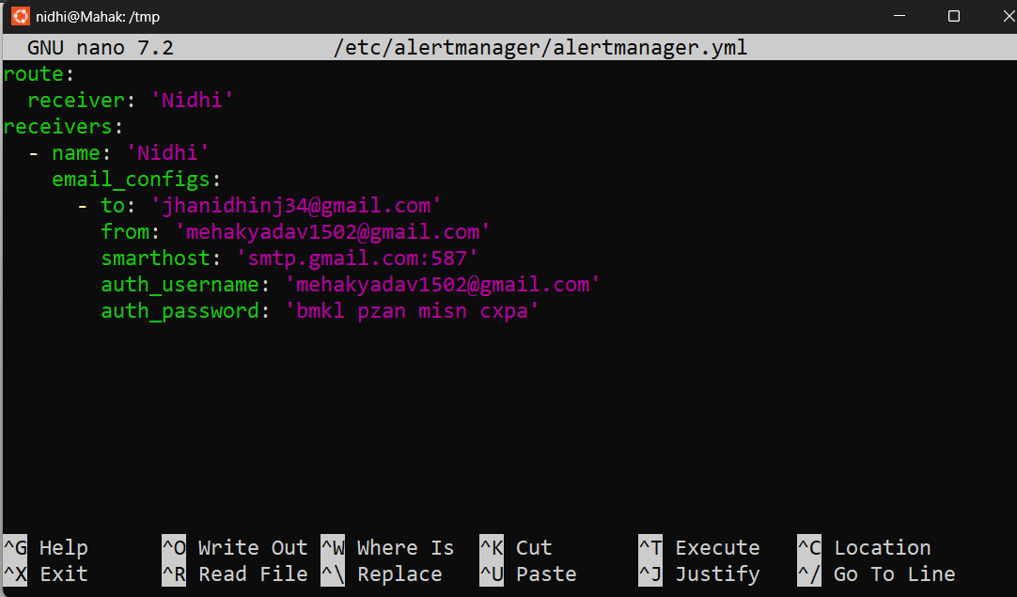

- Press CTRL + O → Enter to save.
- Press CTRL + X to exit.

- Start Alertmanager:
  - alertmanager --config.file=/etc/alertmanager/alertmanager.yml

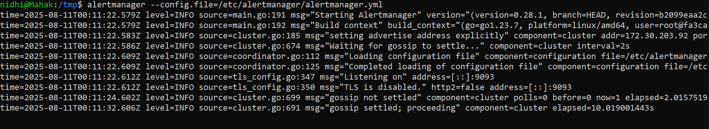

Link Alertmanager to Prometheus
- In your prometheus.yml, add the Alertmanager configuration:
alerting:
alertmanagers:
- static_configs:
- targets:
- 'localhost:9093'



- Restart Prometheus again:
  - sudo systemctl restart prometheus

Display Alerts in Grafana

- Run Grafana in ubuntu:
  - sudo systemctl start grafana-server

- Open Grafana and go to Configuration > Data Sources.
- Add Prometheus as a data source by providing the Prometheus URL (e.g., http://localhost:9090).

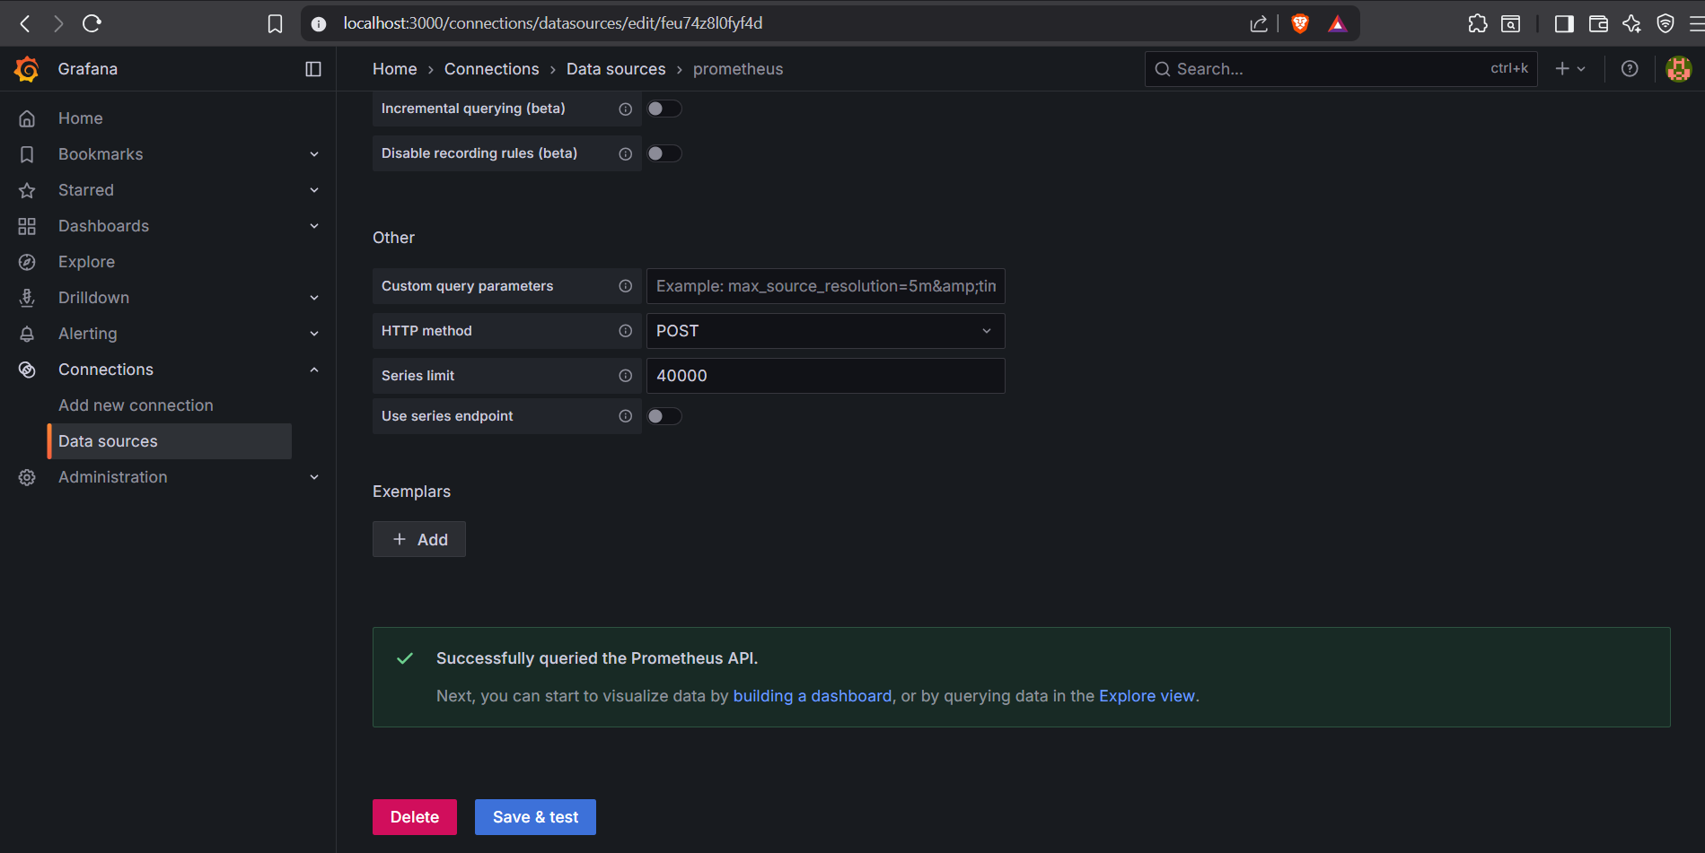

- Go to dashboard New dashboard

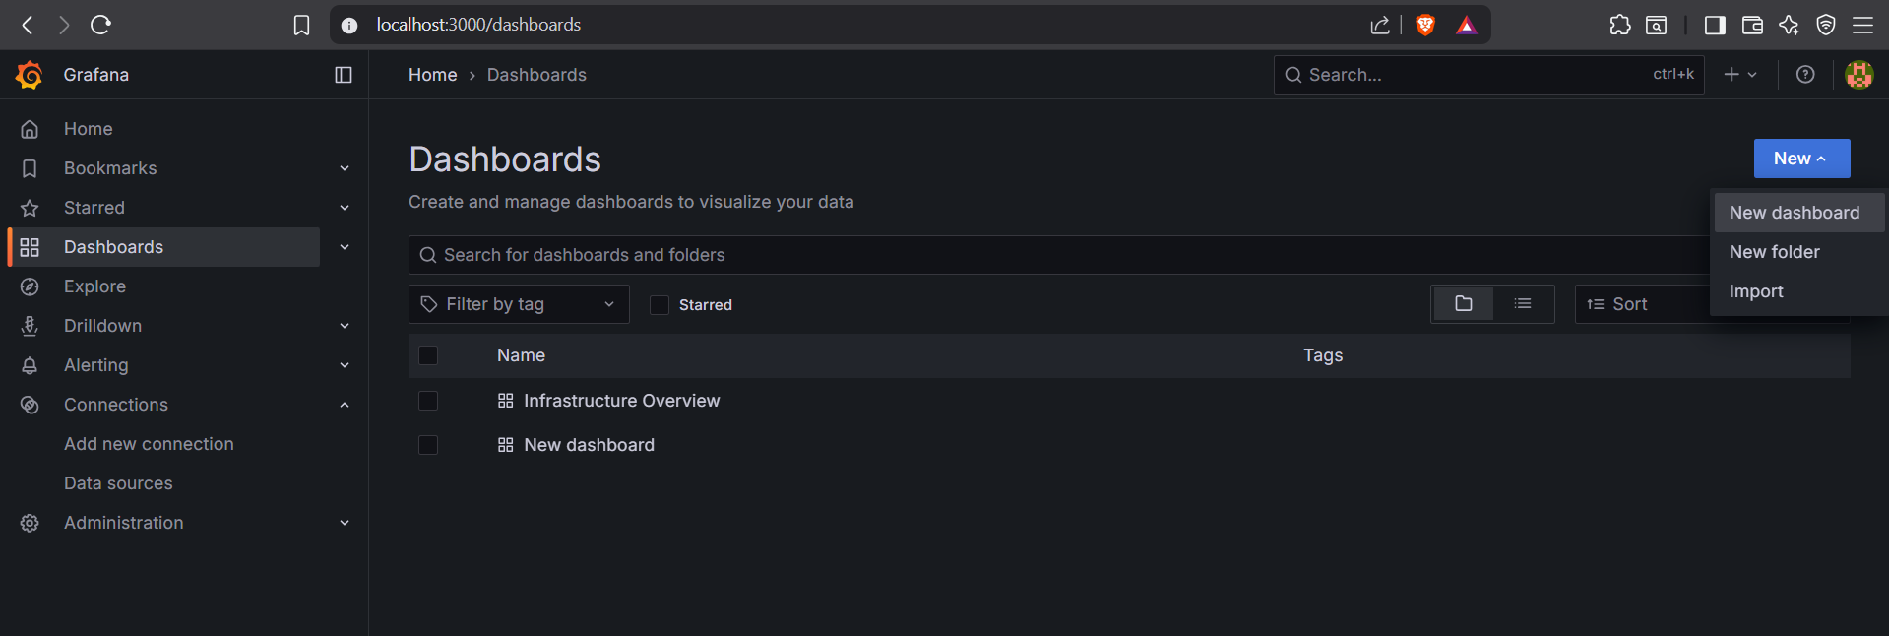

- Add Prometheus as visualization.

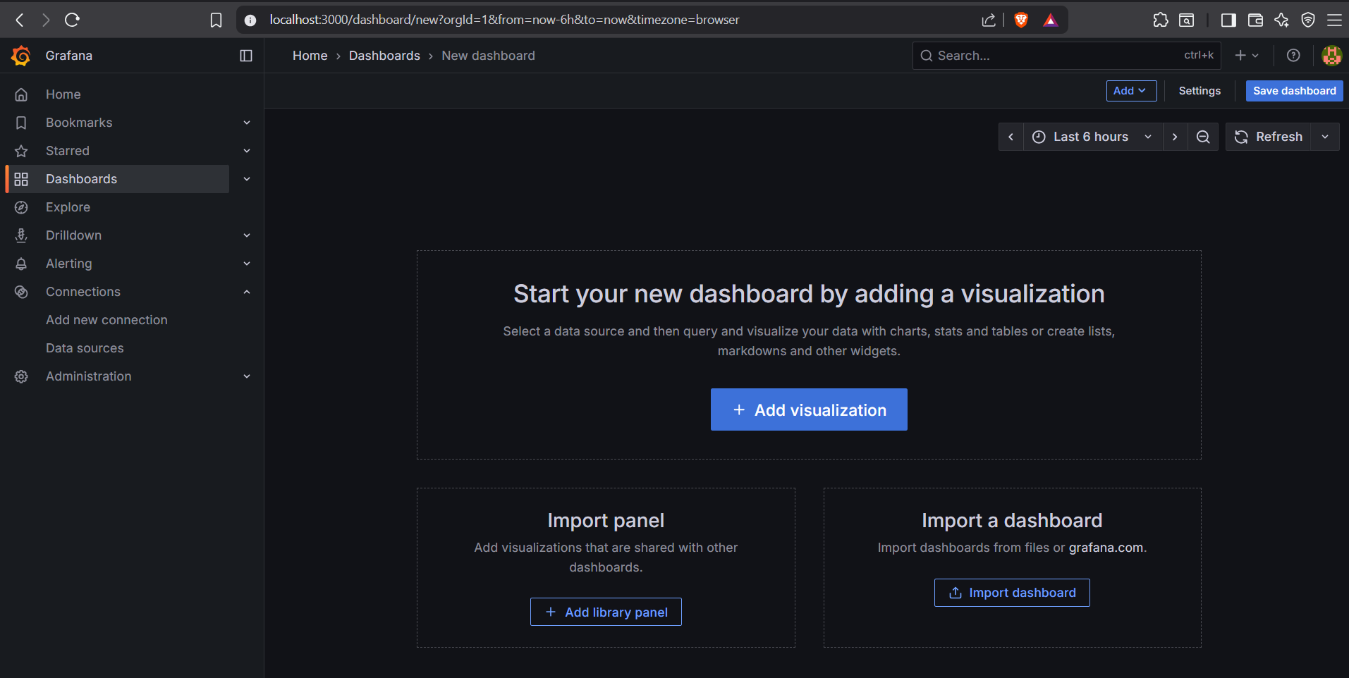

- Select Prometheus

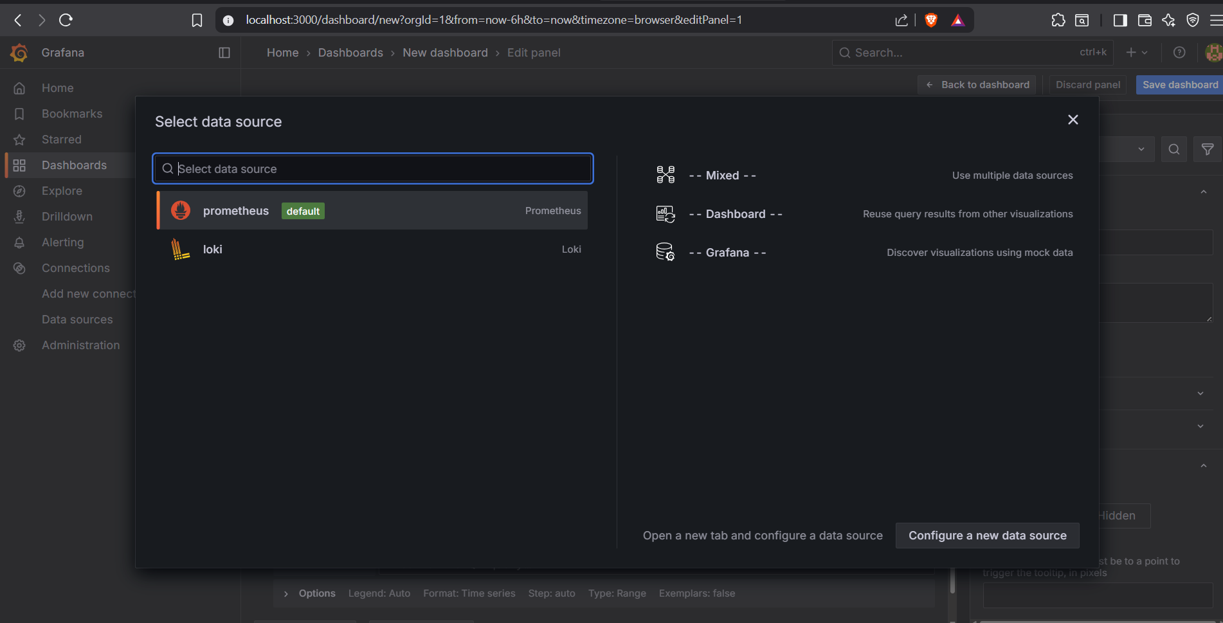

- Try a simpler query in Grafana Explore:

ALERTS

- This shows all alert states, not just firing.
Or query the metric directly in Prometheus UI to verify data exists.

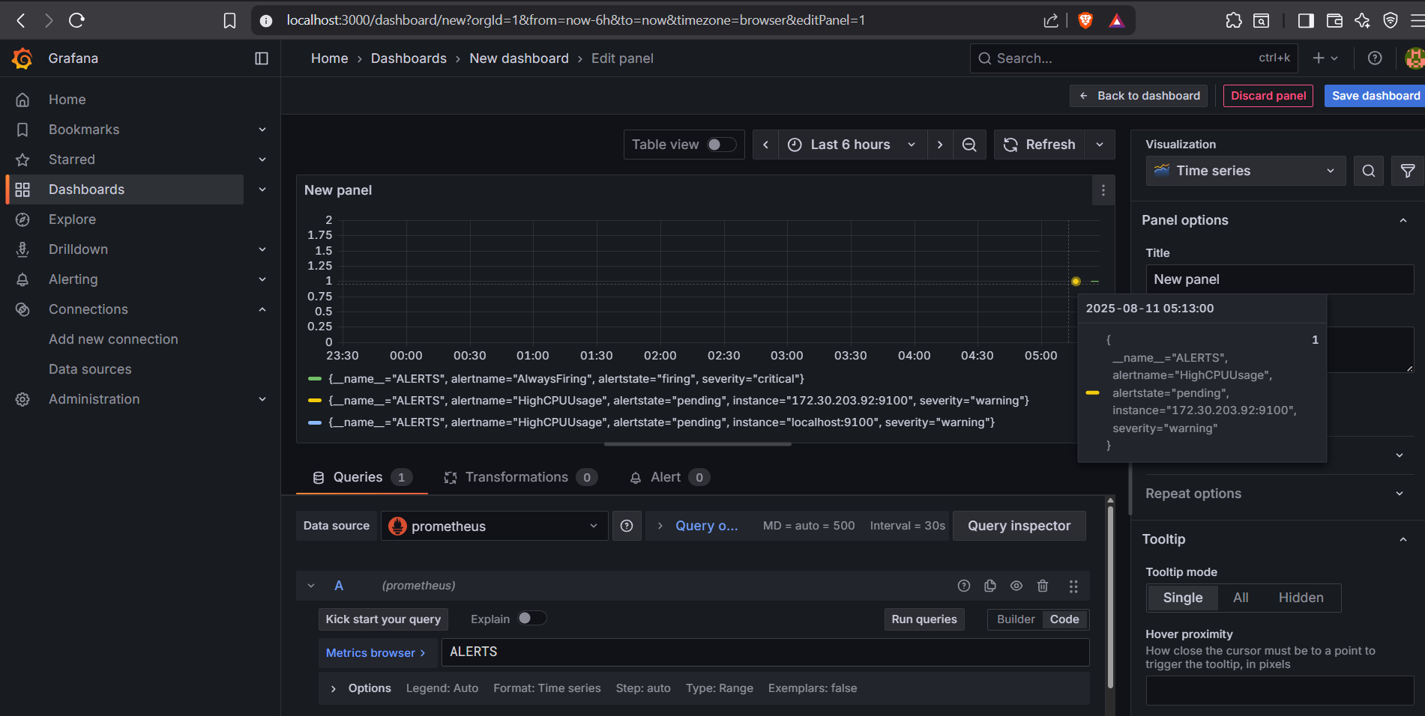

- Check the firing query in Grafana:
ALERTS{alertname="AlwaysFiring", alertstate="firing"}

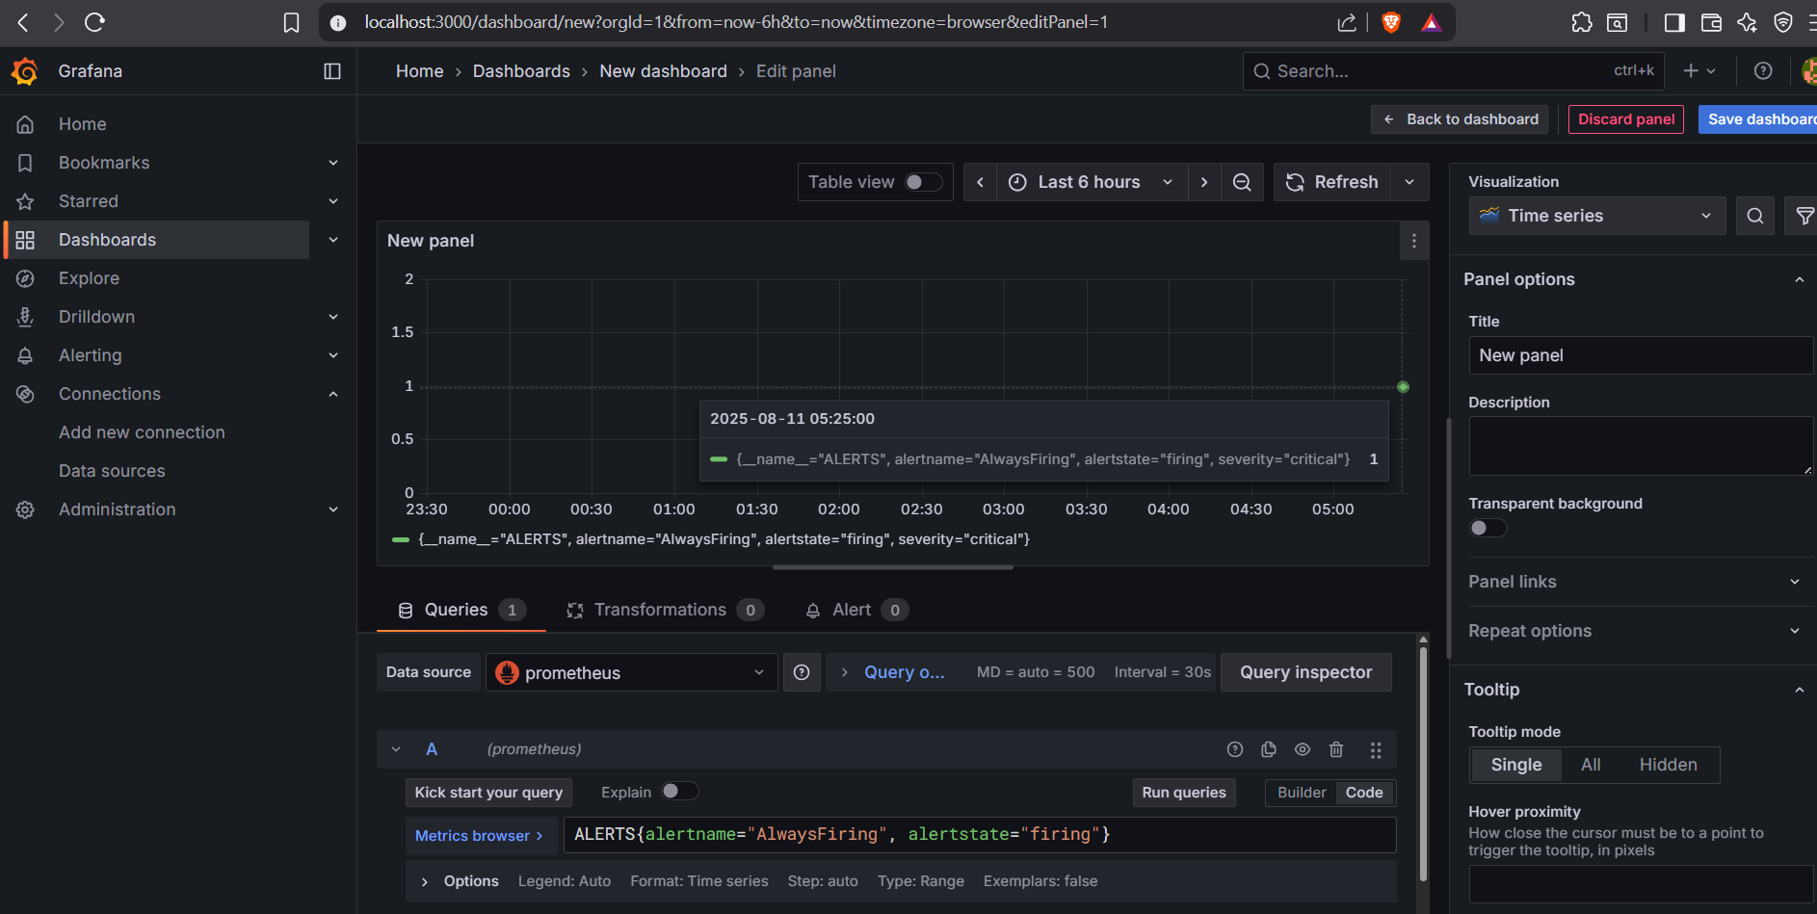

- Go to Alerting Alert rules

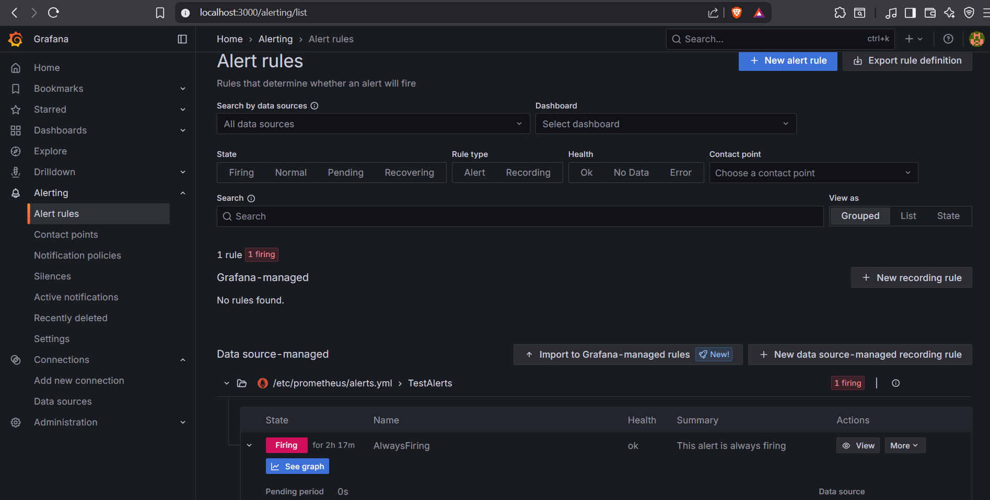

- See graph

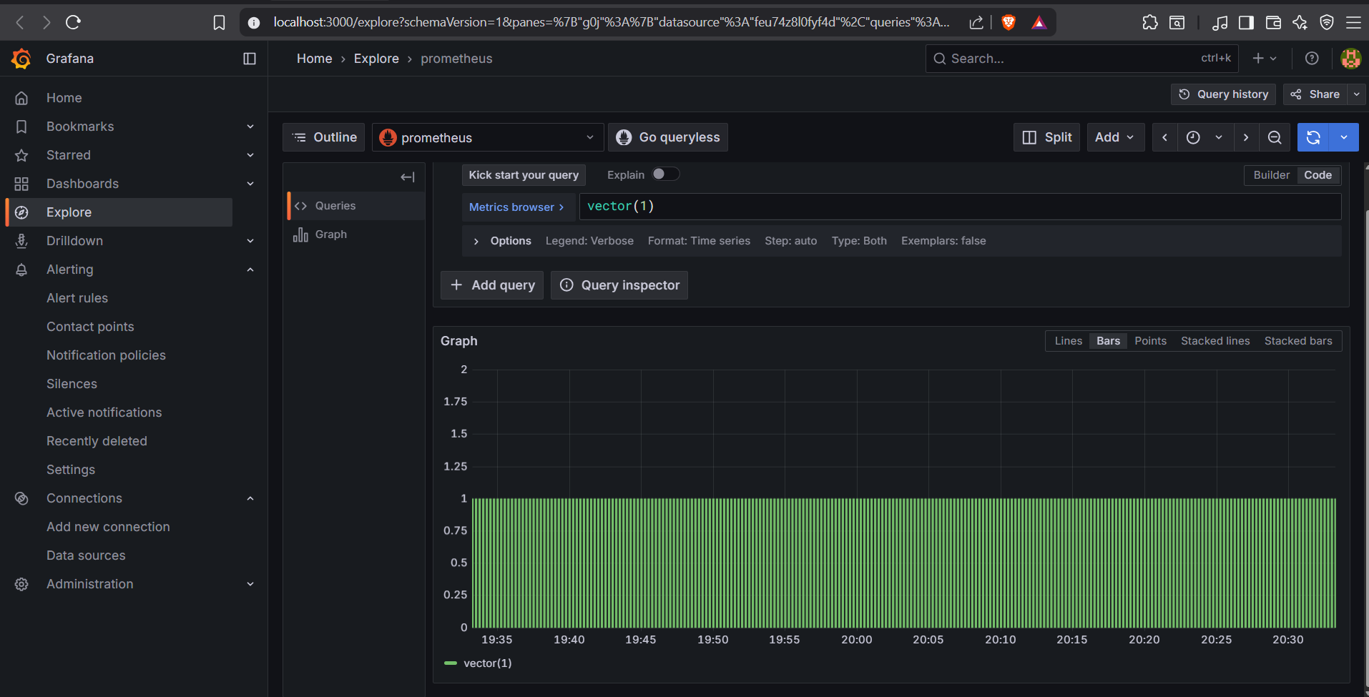

- You can also verify the alert in Prometheus

Go to http://localhost:9090/alerts

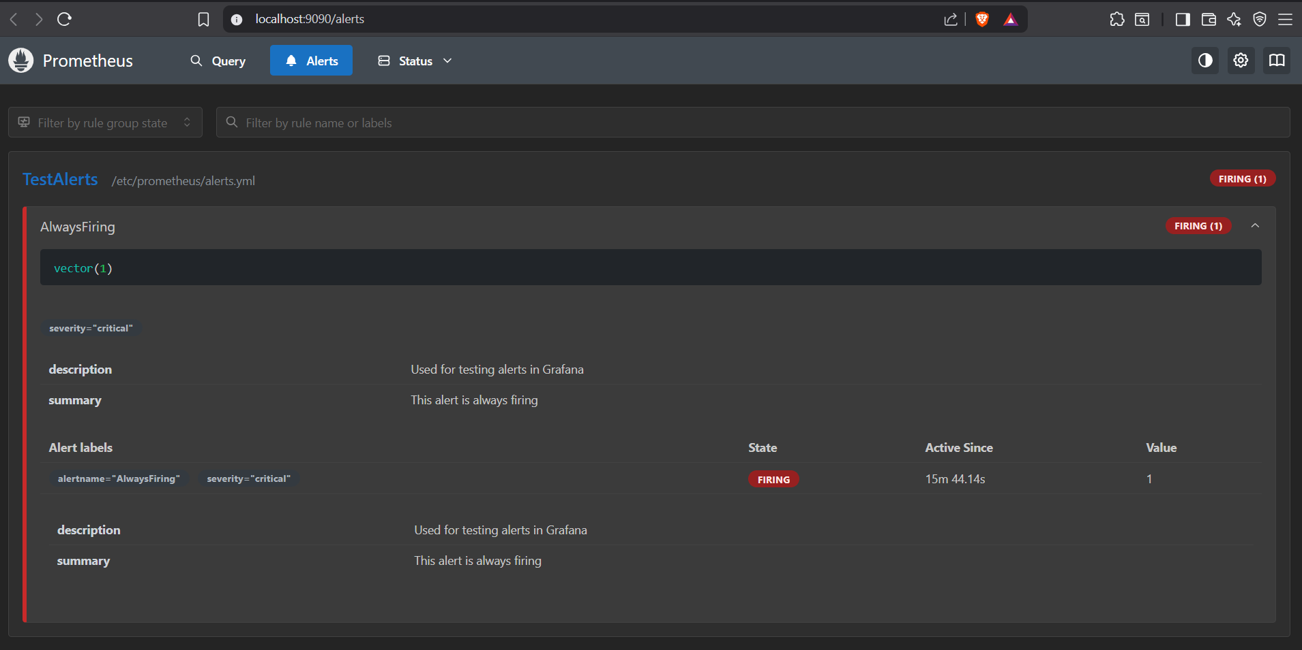

- Check your gmail, you will get a alert notification.

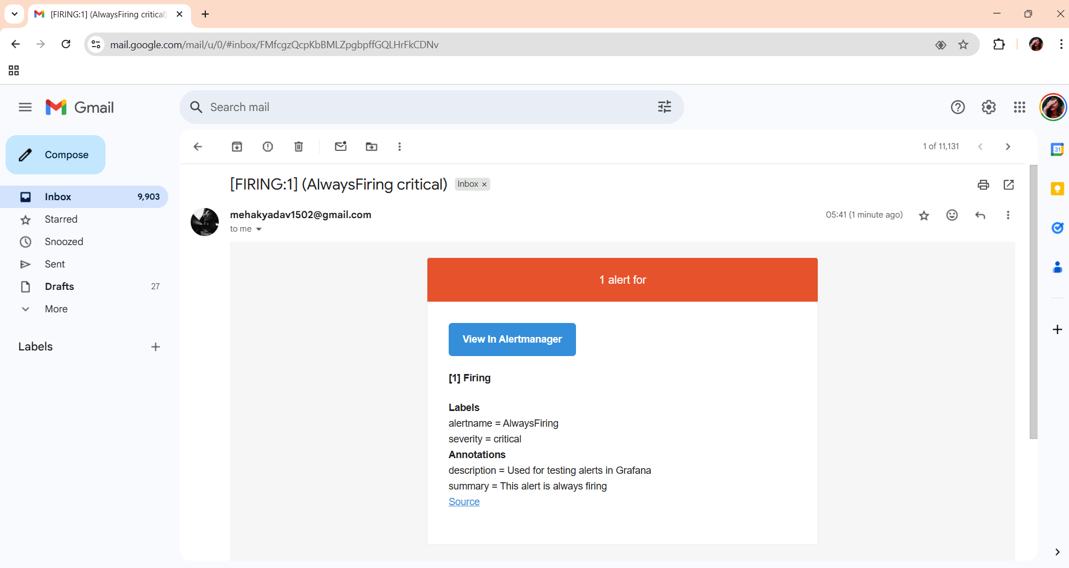

Conclusion
This guide demonstrated how to implement an effective alerting system using Prometheus, Alertmanager, and Grafana. By defining alert rules in Prometheus, linking them to Alertmanager for notification routing, and visualizing them in Grafana, you can create a complete monitoring and alerting workflow.
The example "AlwaysFiring" rule served as a test to validate the setup end-to-end—from alert generation in Prometheus, through routing in Alertmanager, to visual confirmation in Grafana and email notifications. With this foundation in place, you can replace the test rule with real metric-based alerts, customize notification channels, and ensure timely responses to critical system events.

